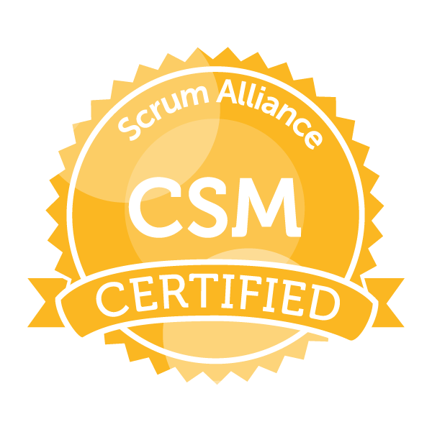
SIVARAMA KRISHNA POLAVARAPU
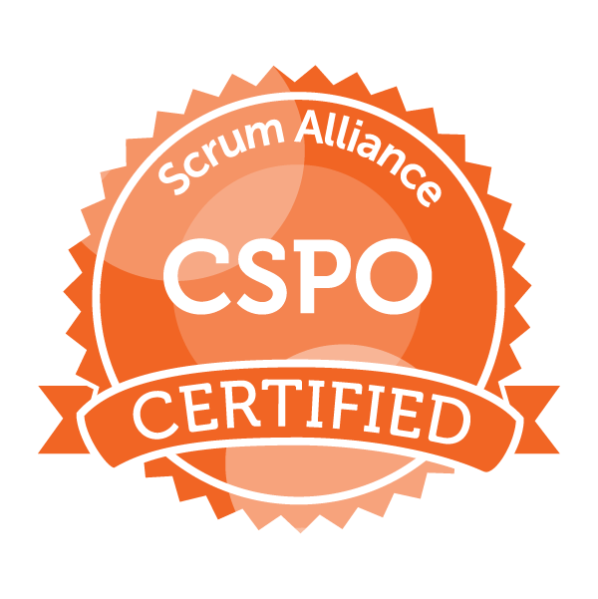
Scrum Master / Project Manager

LinkedIn: linkedin.com/in/sivarama-krishna-polavarapu-3b4b663a

PROFILE SUMMARY:

A dynamic and accomplished Scrum Master and Project Manager with 15 years of experience in leading successful projects and programs across a range of industries. Expertise and knowledge in project management, organizational leadership, and process improvement. Demonstrated capability in managing techniques, methodologies, and best practices to effectively handle complex projects from conception to completion.

PROFESSIONAL EXPERIENCE:

- 15+ years’ experience in Project Management and Agile Scrum Framework.
- Skilled in Agile software development disciplines, such as Scrum Framework and Lean Principles.
- Sprint planning and execution for successful sprint goal.
- Effective management of sprint backlog, product backlog and release planning.
- Use story development and story point estimation techniques.
- Proficient in tools such as Microsoft Project, JIRA, Confluence and other project/program tracking tools.
- Expertise in communicating and resolving issues with stakeholders to meet project objectives. Adept at handling multiple project tasks and working on tight deadlines.
- Excellent problem-solving, troubleshooting, and analytical skills.
- Proficient in Agile methodologies Scrum, Kanban, & Lean.
- Implemented scrum values and techniques through scrum events such as sprint planning, daily scrum, review and retrospectives to manage scrum artifacts.
- Expertise in project management, defining Project Plans, milestones, deliverables, and timelines.
- Developed Risk Mitigation Plan, Communications Plan, SWOT Analysis, Gap Analysis, Impact Analysis, & Change Management. Performance improvement strategies, Monitoring, Controls, and Metrics.
- Expertise in software development life cycle including requirement gathering, analysis, design, development, product launch, and support & maintenance.
- Expertise in enterprise software applications such as Human Resource Management, Compliance Management, Contractor Management & Occupational Health & Safety Management, Client & Order Management Platforms.
- Managing an IT project portfolio of various initiatives, including a customer service application and a customer profiling system.
- Tracking the project metrics such as number of defects, defect density, story point completion and velocity. Analyzing the metrics and implementing CAPA.
- Preparing artifacts for the quality audits, generation of risk reports and risk mitigation processes.
- Continuous Improvement through PDCA method.
- Internal QMS auditing to support organizational compliance.
- Expertise in Agile methodologies, coupled with strong project management skills empowered cross-functional teams to achieve outstanding results.
- Used Kanban boards for Bug Tracking Teams and managed cycle time, throughput and WIP limits efficiently.
- Conducted Daily Scrum Stand up Meeting for well execution of Operational Activity by coordinating with Technical Teams, Development Team, Architect Team, and Testing Team.
- Introduced and implemented Scrum in the Vietnam and Hongkong based teams; significant communication efforts were made to establish a common understanding of required product quality.
- Developed a project governance model for IT projects with focus on providing transparency in project selection, project priority and execution and management reporting.

Client : State Street ,TX Apr 2023 – Present
Sr Scrum Master

- As a Project Manager & Scrum Master at ABN, I have been responsible for overseeing the successful execution of various projects and initiatives, leading agile teams and ensuring efficient delivery of high-quality products and services.
- As a Project Manager & Scrum Master, I have played a pivotal role in managing multiple concurrent projects and ensuring their successful delivery within set timelines and budgets.
- I worked in operations management and was responsible for overseeing the development and implementation of various projects and initiatives related to the operations planning and risk management services offered by the company.
- Some of my key responsibilities included creating project plans, identifying and managing project risks, organizing and facilitating project meetings, and ensuring timely delivery of projects within budget. I also worked closely with cross-functional teams to gather business requirements, develop user stories, and create test plans for new systems and tools that were being implemented.
- Managing risks by identifying, assessing, analyzing, defining, and implementing risk responses, monitoring, and managing them.
- Coached Agile teams on Lean & DevOps principles and practices.
- Creating infrastructures for TDD, BDD, ATDD and DEVOPS (Continuous Integration and delivery pipeline).
- Used PM tools like JIRA, Confluence, MS Excel etc.
- Trained multiple Teams on Scrum, Agile Requirements, and SAFe Principles. Worked with different Coaches to identify Scale Agile process improvement.
- Educated and reinforced scrum methodology and agile framework to team members and key stakeholders.
- Directed and lead development team from project initiation through delivery of final product. Planned and monitored project budget/spending. Guided projects to completion on time, within scope, and on budget.

Client :GOCL Jul 2012 – Aug 2022
Scrum Master / Project Manager

- As a Project Manager & Scrum Master I oversee all the web development activities within the group organization.
- Implementing project management with best practices, efficiency, productivity and a disciplined approach to execution within the project scope and timeline.
- Facilitated Scrum Events and ensuring the scrum process is rigorously followed by the team (Sprint Planning, Daily Scrum, Sprint Review and Sprint Retrospective) for Agile Scrum Methodologies to track progress of the work.
- Worked with SDLC and Agile (hybrid) environment and facilitated Scrum meetings with Developers, QA, BA and Stakeholders for team collaboration and project delivery.
- Project Management Activities and Quality Assurance Objective to ensure top quality in all the deliverables, quality measurement, course correction plans.
- Creating and onboarding project teams, integrating them into the organization and providing a clear vision of the product.
- Mentoring and coaching the team on Scrum Framework, scrum values, Agile methodologies, principles and practices.
- Developed SWOT Analysis for the team, Assessment and identification of potential risk factors and problem solving with eﬀective solutions through corrective actions, preventive actions and risk management.
- Played a major role in all the stages of software development lifecycle like requirement discussion, design, development, unit testing, continuous integration, continuous deployment, release management and maintenance.
- Advising the organization on Agile Project Management practices and implementation of Scrum Framework for product development in various teams.
- Designing, Planning & Execution of various kinds of Agile Training Programs on Lean, Scrum, Kanban, Kaizen, JIT etc.

Client : VIMTA Aug 2008 – Jul 2012
Project Executive

- Clearing obstacles.
- Establishing an environment where the team can be effective.
- Addressing team dynamics.
- Ensuring a good relationship between the team and product owner as well as others outside the team.
- Protecting the team from outside interruptions and distractions.
- Provide solution services and send recommendations on product which brings business to company.
- Provides mock up on the solution and gets reviewed with UX team.
- Collaborates across multiple cross functional teams to skilfully execute on milestones and deliverables in timely manner.
- Reviews test cases and assists QA and management in confirming a bug before a bug fix.
- Performed impact and gap analysis.
- Prioritizes the requirements using MoSCoW and WSJF techniques.
- Facilitated daily stand-up meetings, sprint planning, sprint review, and retrospective meetings to ensure transparency, inspection, and adaptation within the team.
- Acted as a servant leader, removing impediments and fostering a collaborative and self-organizing team environment.
- Managed the product backlog, prioritized user stories, and ensured alignment with product vision and stakeholder expectations.
- Collaborated closely with product owners and development teams to refine requirements, clarify user stories, and ensure successful sprint delivery.
- Coached team members on Agile principles and best practices, promoting a culture of continuous improvement and learning.
- Implemented Agile metrics to track team performance, sprint velocity, and release progress, enabling data-driven decision-making and process optimization.
- Facilitated communication and alignment between development teams, product management, and other stakeholders to mitigate risks and drive project success.

Client :NEERI Nov 2007 – Aug 2008
Project Assistant

- Managed and coordinated multiple projects to ensure they are completed on time and on budget.
- Oversee the entire project life cycle from initiation through planning and execution until project closing.
- Gathered requirements and prepared specifications documents and project documentation.
- Organized and planned project tasks and schedules including scope, cost, time and quality.
- Optimization of project deliverables, schedule and budgeting.
- Coordinated and worked with proposal teams to develop cost estimates and project plans.
- Coordinated with project teams, organizing project meetings, preparing minutes and executing actions.
- Created presentations and reports to communicate project status to the stake holders and project participants.
- Facilitated, communication and collaboration across departments to ensure projects are completed successfully.
- Ensured meeting company goals and strategies to align projects with business priorities.
- Lead projects and delegation of work to team members based on their skills and expertise.

